THE ACOUSTIC GUITAR

Martin Cummins
DKIT
martincummins@live.ie

ABSTRACT
The paper deals with the anatomy and properties of an acoustic guitar. Although there are many different shapes and sizes, they all share the same acoustic properties. A brief history is given and a breakdown of a guitar's working components. There are some formulae for determining accurate measurements required to produce controlled pitches. String harmonics are covered along with tonal characteristics of materials used in construction. Bracing has been examined and an explanation given as to its importance for tone and strength.
- INTRODUCTION
There are many types of acoustic guitar available today. Although they all share similarities, there is an endless combinations of materials, shapes and sizes from which to choose. For the purpose of this paper, the focus is on the popular 'dreadnought' style, which features rounded shoulders, with the neck joining the body at around the 14th fret.
This paper intends to inform the reader about the different components that contribute to manufacturing a dreadnought style acoustic guitar, followed by an explanation of some the critical factors involved in making the instrument playable.
- bACKGROUND HISTORY
There are many stories surrounding the invention of the acoustic guitar. Depending on location, different versions of the instrument lay claim to being the original. The Persian word tar, which means string, links a number of early iterations such as the kithara from Greece, chartar from Persia and the sitar in India. The oldest surviving guitar-like instrument is a tanbur from Egypt It is approximately 3500 years old and is on display at the Archaeological Museum in Cairo. (String Ovation, 2016)
The modern version of the guitar is believed to have originated circa 16th century in Spain. This instrument had three pairs of strings, and one single string, arranged as a four stringed instrument, similar to a mandolin. This was tuned to C, F, A and D. Over the years, two extra strings were added and the pairs reduced to single strings leaving us with the six string guitar of modern times. The standard tuning of E, A, D, G, B, E, has been around since the 1800's.
The 19th century saw many innovative changes, which resulted in the classical guitar version we see today. Pioneering luthier Antonio de Torres developed a technique, still widely used, known as 'bracing'. Bracing plays a major role in determining the tone of a guitar, whilst also providing strength to the instrument. To enable better tone, the guitar top (soundboard) needed to be thin in order to vibrate when a string was plucked. Thinner wood meant less strength and warping was more likely to occur. Bracing allowed Torres to produce instruments that were far superior to the other guitars of the era. He did not invent the technique, but he refined it to such an extent that his design is the blueprint for modern bracing techniques.
Another innovator in the field of luthierism was Christian Frederick Martin. Martin further developed the design by adding steel strings as opposed to cat gut or nylon employed by other makers. His X brace designs are also widely appropriated today.
- bASIC STRUCTURE
3.1 Overview
The acoustic guitar consists of 3 main elements: the body, the neck and the strings. These items function in tandem to produce the sound of the instrument. Fig 1. below includes the rest of the crucial elements that make an acoustic guitar playable.

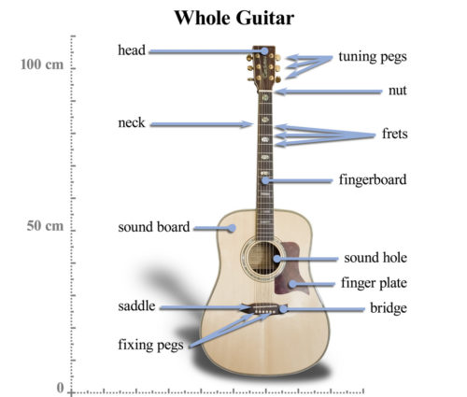
Copyright: © 2018 Martin Cummins. This is an open-access article dis- tributed under the terms of the Creative Commons Attribution License 3.0 Unported, which permits unrestricted use, distribution, and reproduction in any medium, provided the original author and source are credited.

Fig 1. Guitar Anatomy (Nate, 2015)

3.2 The Body
The main function of the guitar body is to act as an amplifier, coupling the energy of the vibrating strings to the air around the guitar. The body of the guitar provides a resonant cavity from where the sound of the plucked string is amplified. The curved shape is contoured to fit the player comfortably while sitting, as well as providing strength and minimising standing wave resonances within the instrument.
3.2.1 Soundboard
The top of the guitar, or soundboard is usually made from wood chosen for its strength and acoustic properties. It is the most important part of the structure as also resonates as the strings are plucked. It needs to be light but strong; rigid but flexible and of course pleasant to look at. The lighter the material, the quicker the soundboard can respond to the player. It also requires less energy to vibrate, however a balance must be struck between strength and lightness. The soundboard is under immense pressure from the pull of the strings, even before a player adds extra stress while plucking or strumming some chords.
3.2.2 Sound Hole
The sound-hole of an acoustic guitar provides an escape for the resonating air inside the guitar body. The sound-hole forms a low frequency Helmholtz resonator that helps to extend the guitars bass response by flattening out the main resonant peak of the soundboard (top surface of guitar).
3.2.3 Bracing
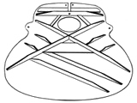

Fig 2. Typical Martin Guitars bracing pattern (Martin, C.F, 2018)

Bracing is a technique used to strengthen the relatively thin soundboard of the guitar where needed, and also to help the overall tone by controlling the resonant modes of the instrument. It is achieved by using a pattern of bars of wood called braces, which are glued to the inner surfaces of the soundboard. Bracing the sides and back can add strength to the guitar, but it is more important to have the soundboard properly braced, as this is where most of the tone originates. In addition, braces are often used to tune the back of the guitar in relation to the soundboard.
There are many styles and variations of bracing patterns between manufacturers but they all provide the same service. Larger pieces of brace will add strength but smaller, lighter pieces can be positioned to help modify tonal output.
A popular style developed by Martin Guitars is the X style. Fig 2. Shows the thicker struts add strength while the smaller pieces help to modify or tame the resonance of the instrument.
3.2.4 Bridge, Saddle and Fixing Pegs
The bridge of the guitar is the point on the instrument where the strings make contact with the resonant soundboard/body. The bridge also pre-determines the distance between each string and the ¹scale length of the finished guitar. The saddle helps to evenly transfer the string vibrations to the soundboard and provides extra height and support for the bridge. The fixing pegs anchor the string in place through the saddle and into the underside of the soundboard. From this anchor point, the strings are stretched over the bridge and all the way across the body and up the neck, until they make contact again at the nut, after which they are tensioned using the tuning pegs/machine heads.
3.2.5 The Scratch Plate
This element of the construction serves to protect the soft wood of the soundboard from damage and/or scratches from the players fingers or guitar pic. Usually made of tough plastic, they come in all shapes, sizes and colours and are glued on to the instrument contributing to a pleasing aesthetic in most cases. Some argue that tone may suffer as the flexibility of the soundboard is compromised, but any difference in sound is subjective.
3.3 The Neck
The neck is the second of the major construction elements of a guitar. It is usually constructed of a ²quarter-sawn hard wood, like mahogany or maple, and sometimes different species of wood glued together and laminated. It is usually bolted on to the body but sometimes glue and careful joinery is enough. The neck is often strengthened using a metal rod (or two) resting in a channel that has been carved or routed along its entire length. This metal rod (known as the 'truss rod') can be tightened or loosened via an allen key, allowing the neck to be straightened against the tension applied to it by the strings.
3.3.1 The Fret Board
The fretboard is a separate piece of hard wood (usually rosewood or ebony) which is glued onto the neck covering the truss rod channel. Depending on the design of the instrument, the 'frets' are installed into the fretboard at varying distances apart. The frets themselves are thin strips of smooth metal, cut to the width of the neck and placed along it in grooves that have been carefully routed out.

¹A guitar's scale length is calculated by measuring the distance from the front edge of the nut, where it butts against the end of the fingerboard, to the centre of the 12th (octave) fret, then doubling that measurement. (Macdonald, 2018)

²Quarter-sawn is a carpentry term which indicates the way in which the lumber has been cut. Quarter-sawing takes more time, greater skill and larger trees, all of which make quarter-sawn instrument necks more expensive than their plain-sawn counterparts. (Owens, 2018)
There are ³online calculators that will work out the distance between each fret for a given scale length and number of frets. It is important that they are placed accurately according to the measurements because each fret represents a new note for each string. They are spaced apart by a semi-tone. There are twelve semitones in a musical scale which make an octave, therefore the 12th fret is always an octave above the same string plucked open.

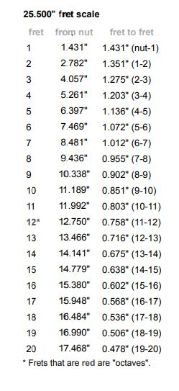
Fig 3. Fretboard Spacing Calculator (Macdonald, 2018)
3.3.2 The Nut
The nut is placed at the top of the neck, usually where the fretboard stops. Commonly made from hard plastic, high end guitars often use brass or bone to achieve better tone and more sustain. The nut is critical because, in conjunction with the bridge, it determines the absolute length of the string and therefore the frequency of the note that is produced when said string is plucked.
3.3.3 Headstock and Tuning Pins
The headstock and tuning pins are responsible for finally locking the strings in place while allowing each string to be tuned. The string is anchored at the bridge and stretched along the neck and over the nut. The nut will have six grooves cut in to it on order to keep the same distance between each string.

³The fret positions or intervals have traditionally been determined by a mathematical relationship known as the “rule of 18”, or more precisely: 17.817153. The rule basically states that: If you divide the scale length (the distance from the nut to the bridge) by 17.817, you end up with the first fret position starting from the nut end of the fingerboard. If you then take the scale length minus the first fret distance and divide the remainder by 17.817, you end up with the second fret position located from the first fret. Next if you take the scale length minus the first and second fret distances and divide the 2 of 19 remainder by 17.817, you end up with the third fret position located from the second fret. This process is repeated until all frets required are located. (Magliari, 2006)
Once the string is settled in its groove, the end is threaded into the tuning pin (machine head) and secured by winding several times until taught. Tightening the string further raises the pitch of the note that it produces, and vice versa.
3.4 Strings
The strings provide the guitar with a voice. A dreadnought acoustic will require six strings of various thickness. Each one occupies a designated slot from bridge to nut and on through to the machine head for tuning. For right handed players, looking down in the playing position, the thinnest string is furthest away. This is called 'e 1st' as it is tuned to E and is the first string. Lowercase lettering indicates that it is the thinnest string. Each subsequent string is slightly thicker and the notes produced are pitched lower. All six strings produce the notes
E, A, D, G, B, e 1st
- Sound Propagation
When a guitar string is plucked, it vibrates. These vibrations are transmitted through the bridge and saddle and onto the soundboard. The soundboard vibrates and the body of the instrument amplifies the sound. The sound-hole transmits the amplified sound back out to the listener. Most of the lower frequency content is propagated through the sound hole while the higher frequencies are produced mainly from the soundboard.
Guitar strings are designed to produce a single note, at a given tension, weight and length. A guitar string has boundaries at both ends, is elastic and can vibrate. The vibrations of the string are called standing waves.
When an open (un-fretted) string is gently plucked, the vibrations produce a standing wave. If the string is plucked harder, the sound changes. This is because overtones, or harmonics are added to the fundamental frequency. The fundamental frequency is half a wavelength which is the lowest frequency of the string.

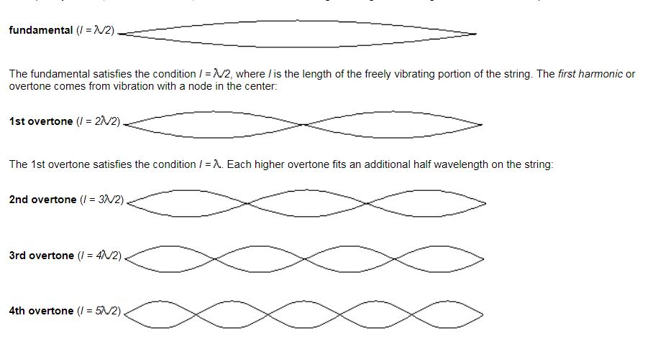

Fig 4. Example of Guitar String Harmonics

Other strings also pick up the vibrations from the saddle and add their own vibrations. Therefore, the sound you hear from a guitar for any given note is a blend of many complimentary frequencies. The diagram in Fig 4. shows the fundamental followed by four harmonics. Note that the first harmonic has one node in the centre, the second has two and so on.
- Tone
The tone of the instrument is greatly influenced by the type of wood used for the various elements. There are many types of wood used for guitar construction, and many arguments over which is best. Spruce and maple are often used in soundboard construction, as they are light yet strong. They are known for imbuing the guitar with bright, crisp tones, while mahogany produces a darker, more earthy tone, and is often used for the back and sides. The size of the guitar as well as the type (if any) of bracing used will also affect the tone.

CONCLUSIONS
In conclusion, all acoustic guitars share the same properties regardless of size or shape. The design and construction of the instrument adheres to strict mathematical formulae for identifying crucial measurements such as fret spacing and bridge position. The harmonic series of a guitar string has been examined. Although the equations may be difficult to remember, they can all be found online with ease.

REFERENCES
- String Ovation, 2016. String Ovation. [Online] Available at: https://www.connollymusic.com/stringovation/history-acoustic-guitar [Accessed 7 December 2018].
- Nate, B., 2015. Six String Acoustic. [Online] Available at: https://sixstringacoustic.com/acoustic-guitar-anatomy-diagram-and-definitions [Accessed 10 December 2018].
- Martin, C.F, 2018. Martin Guitar Company. [Online] Available at: https://www.martinguitar.com/features-materials/bracing-patterns/ [Accessed 7 December 2018].
- Macdonald, S., 2018. Scale Length Explained. [Online] Available at: https://www.stewmac.com/How-To/Online_Resources/Learn_About_Guitar_and_Instrument_Fretting_and_Fretw/Scale_Length_Explained.html [Accessed 9 December 2018].
- Owens, J., 2018. Fender.com. [Online] Available at: https://www.fender.com/articles/tech-talk/go-with-the-grain-the-many-benefits-of-a-quartersawn-neck/ [Accessed 9 December 2018].
- Macdonald, S., 2018. Fret Position Calculator. [Online] Available at: https://www.stewmac.com/FretCalculator [Accessed 9 December 2018].
- Magliari, G., 2006. Method for Positioning Musical Instrument Frets. [Online] Available at: http://www.luth.org/images/web_extras/al116/MagliariFretComp.pdf [Accessed 10 December 2018].

